# Brainstorming & Idea Prioritization Template

|  |  |
| --- | --- |
| Date | 30 October 2025 |
| Team ID | NM2025TMID02969 |
| Project Name | Calculating Family Expense Using ServiceNow |
| Maximum Marks | 4 Marks |

**Brainstorming & Idea Prioritization Template**

Brainstorming provides a creative environment that encourages team members to collaborate and generate innovative ideas. In this project, our goal was to develop a system for calculating and tracking family expenses using ServiceNow. The brainstorming session allowed us to identify key problems, generate solutions, and prioritize feasible ideas for implementation.

**Step 1: Team Gathering, Collaboration and Problem Selection**

Our team collaborated to identify a real-world problem that could be automated using ServiceNow. After several discussions, we selected 'Calculating Family Expenses' as our project focus. The challenge was to build a system that could record, categorize, and analyze household expenses efficiently, providing insights through reports and dashboards.

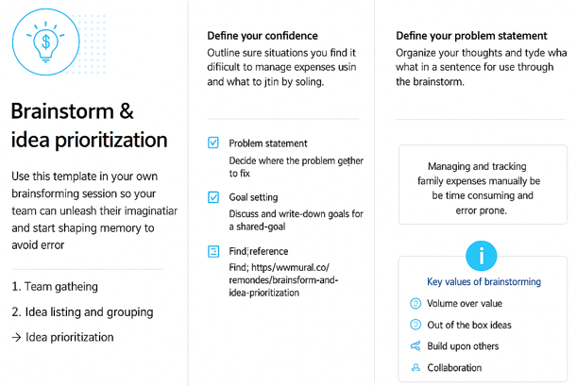

**Step 2: Brainstorming, Idea Listing and Grouping**

We listed all potential ideas for developing the system using ServiceNow. Each idea was discussed, grouped, and evaluated based on feasibility and impact.

Ideas generated included:

* Creating a user-friendly expense submission form in ServiceNow.
* Categorizing expenses (e.g., groceries, utilities, education, travel).
* Automating total monthly expense calculations.
* Generating visual expense reports and analytics.
* Sending automated budget alerts when limits are exceeded

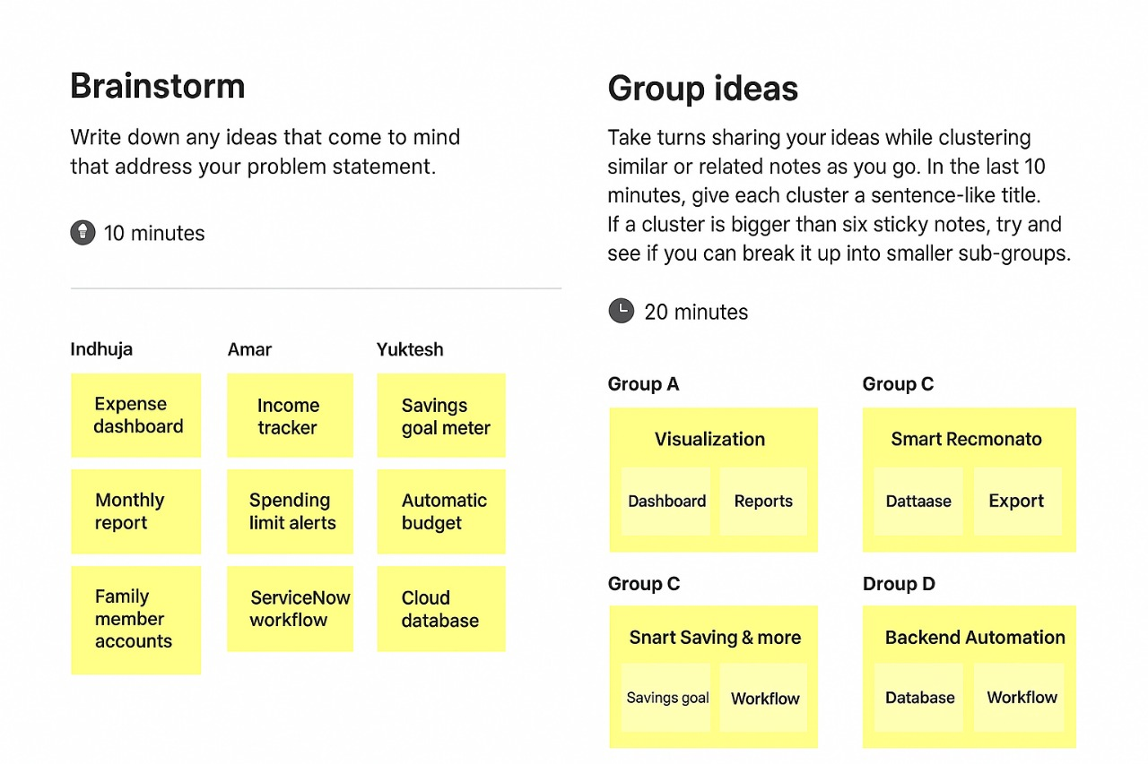.

**Step 3: Idea Prioritization**

After listing all ideas, we used prioritization techniques like impact vs. feasibility analysis. High-impact and easy-to-implement ideas were chosen for the project’s first phase.

Prioritized ideas:  
1. Expense recording and categorization form.  
2. Automated monthly calculation module.  
3. Dashboard for visualization.  
4. Alert system for budget control.

